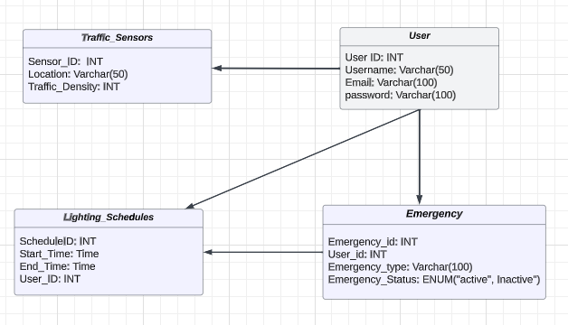***Database Design Schema -***

***Users Table:***

*Purpose*: Manages information about users interacting with the system.

*Importance*: Essential for user authentication, access control, and associating users with specific lights they control.

***Lighting_Schedules Table:***

*Purpose: Stores data related to individual street and highway lights.*

*Importance: Critical for controlling and monitoring the status, brightness of lights. Also associates each light with a specific user****.***

***Emergency Table:***

*purpose: Stores information about the emergency events that have been triggered by the devices*

*Importance: Facilitates quick identification and classification of emergency types. Enables logging and monitoring of emergency events for rapid response.*

***Traffic_Sensors Table:***

*Purpose: Records data from sensors monitoring traffic density.*

*Importance: Enables the system to dynamically respond to variations in traffic flow, optimizing lighting for safety and energy efficiency.*

***IN Terminal***

***Step 1:***

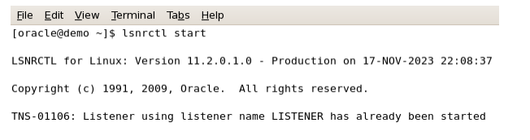

***Step 2:***

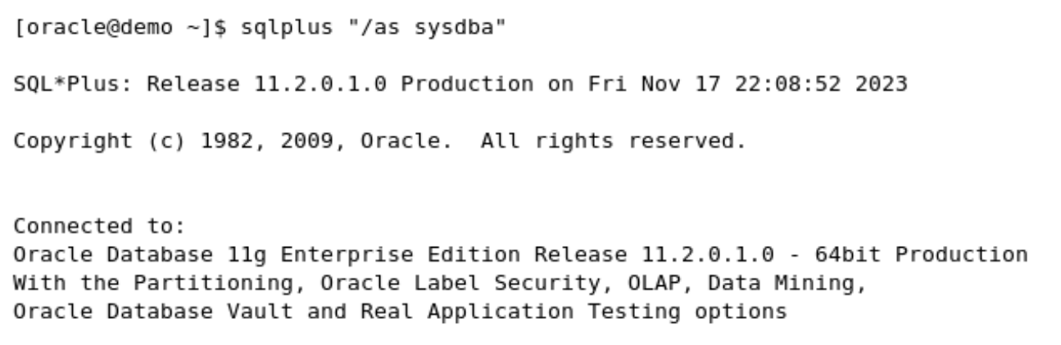

***Step 3:***

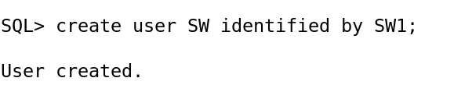

***Step 4:***

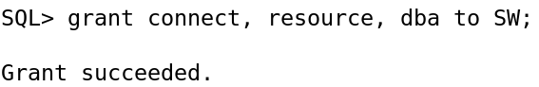

***Step 5:*** establish a connection

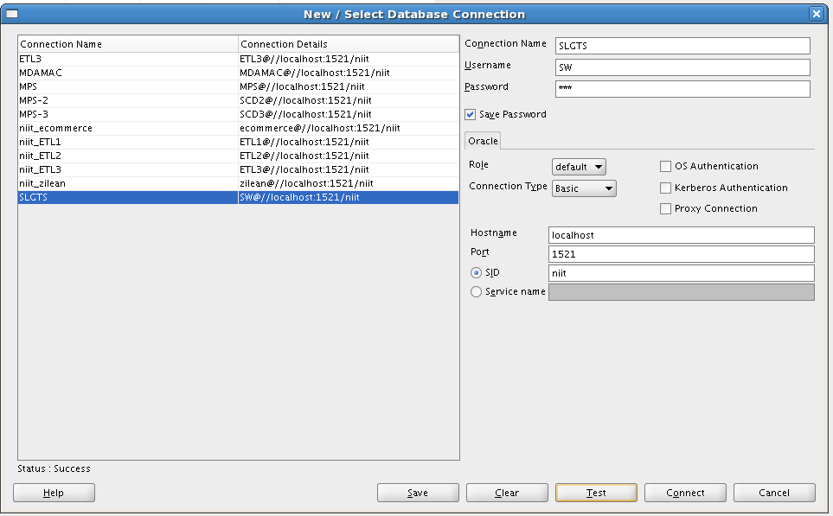

***Step 6:*** *Create Table*

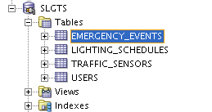

|  |  |  |
| --- | --- | --- |
| ***Column Name*** | ***Data Type*** | ***Description*** |
| *user_id* | *INT* | *Unique identifier for the user (primary key)* |
| *username* | *VARCHAR (50)* | *Username for the user* |
| *email* | *VARCHAR (100)* | *Email address for the user* |
| *password* | *VARCHAR (255)* | *Password for the user* |

***User Table:***

***Lighting_Schedule Table:***

|  |  |  |
| --- | --- | --- |
| ***Column Name*** | ***Data Type*** | ***Description*** |
| *schedule_id* | *INT* | *Unique identifier for the lighting schedule (primary key)* |
| *user_id* | *INT* | *Foreign key to the User table* |
| *start_time* | *TIME* | *Time when the lighting schedule starts* |
| *end_time* | *TIME* | *Time when the lighting schedule ends* |

***Emergency_Event table***

|  |  |  |
| --- | --- | --- |
| ***Column Name*** | ***Data Type*** | ***Description*** |
| *emergency_id* | *INT* | *Unique identifier for the emergency event (primary key)* |
| *user_id* | *INT* | *Foreign key to the user table, referencing the device triggered by the emergency* |
| *emergency_type* | *Varchar (50)* | *Type of emergency (fire, intrusion, etc.)* |
| *emergency_status* | *Varchar (50)* | *Status of the emergency (active or inactive)* |

***Traffic_Sensors Table:***

|  |  |  |
| --- | --- | --- |
| ***Column Name*** | ***Data Type*** | ***Description*** |
| *sensor_id* | *INT* | *Unique identifier for the traffic sensor (primary key)* |
| *location* | *VARCHAR (50)* | *Location of the traffic sensor* |
| *traffic_density* | *INT* | *Measured traffic density* |